Day 4: Network Cable Types and ToolsTheory

Task 1 :- List 3 key differences between Ethernet cables and fiber optic cables, and give one real-world example where each type would be used.

ANS :-
Features /Key Functions | Ethernet Cable | Fiber Optic Cable
Material | It is use copper wires to transmit signals via electricity, | It is use thin glass or plastic strands to transmit signals via light pulses.
Speed & Distance | It’s slow down over longer distances (usually limited to 100 meters) | It’s deliver significantly higher speeds over miles without signal loss.
Interference | It can suffer from electrical or electromagnetic interference; | It are completely immune to electrical noise.
Best Used For | It is for Short-distance local connections | It is for High-speed, long-distance backbones
Real-World Example | It Connecting a gaming PC or TV directly to a home Wi-Fi router | It Connecting high-speed servers inside a data center or across a college campus backbone

Task 2 :- Draw and label a diagram showing the internal wiring of a straight-through Ethernet Cable, indicating the color of each wire and its pin number.

ANS :-

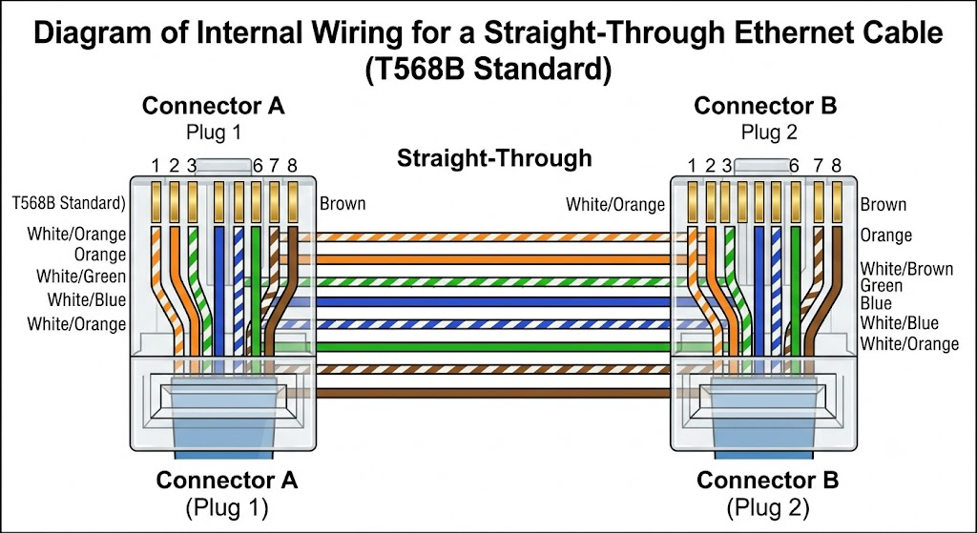

Task 3 :- Watch a YouTube video demonstrating how to use an RJ45 crimper, then write a step-by-step guide on how to attach an RJ45 connector to a CAT6 cable.

ANS :-

Step 1: Strip the Cable Outer Sheath :-
Slide a rubber strain-relief boot onto the cable first if using one. Place end of the CAT6 cable into the stripper section of your RJ45 crimper. Gently squeeze and spin tool around cable to score outer jacket, then pull it off to reveal about 1.5 inches (4 cm) of internal wires.

Step 2: Untwist and Cut the Plastic Core :-
Untwist the 4 pairs of wires so you have 8 individual strands. Snip off the plastic spine (the center plastic core separator) as close to the outer jacket as possible using the cutting blade of your crimper.

Step 3: Line Up the Wires (T568B Standard) :-
Straighten the wires with your fingers and arrange them flat, side by side, in this exact order from left to right:
1. White/Orange
2. Orange
3. White/Green
4. Blue
5. White/Blue
6. Green
7. White/Brown
8. Brown
Step 4: Trim the Wires Straight
Pinch the wires firmly between your thumb and index finger to keep them in order. Use the wire-cutting blade on your crimper to make a clean, straight 90-degree cut across all wires, leaving about 0.5 inches (1.3 cm) of exposed wires.

Step 5: Push Wires into the RJ45 Connector
Hold the transparent RJ45 plug with the locking plastic clip pointing down (gold pins facing up). Carefully push the wires straight into the plug. Ensure all 8 copper wire tips touch the very front inside edge of the connector and the outer jacket extends inside the back of the plug for strain relief.

Step 6: Crimp the Connector
Slide the RJ45 connector all the way into 8P port on your crimper. Squeeze handles together firmly until tool fully closes and releases. This pushes the gold contacts down into wires and locks the plastic tab onto the outer jacket.

Task 4 :- Imagine you are setting up a gaming café with 10 PCs for LAN gaming. Decide which cable type (Ethernet or fiber optics) and which tool (RJ45 crimper or fiber cleaver) you would use, and explain your choices in 3-4 sentences.

ANS :-

For a 10-PC LAN gaming setup, Ethernet cables (CAT6) and a RJ45 crimper are the best choice. Ethernet cables easily handle high-speed 1 Gbps to 10 Gbps LAN gaming over short distances in very low cost. They are also easy to customize and repair using an affordable RJ45 crimper. Fiber optic cables and cleavers are unnecessary and too expensive for short indoor connections. That’s why RJ45 Crimper is best for this.

